Natural versus Synthetic Repellents for Aedes aegypti: A Systematic Review and Meta-Analysis of Efficacy and Protection Duration

Background: Aedes aegypti is the primary vector of dengue, Zika, chikungunya, and yellow fever, creating a substantial public health burden in tropical and subtropical regions. Personal protective measures, particularly topical and wearable repellents, remain practical options for reducing mosquito bites. However, the comparative efficacy and protection duration of natural botanical repellents and synthetic chemical repellents against Ae. aegypti have not been comprehensively quantified.
Methods: PubMed, Scopus, Web of Science, and Embase were searched for studies published from 2004 to 2025. Eligible studies reported protection percentage (PP%) and/or complete protection time (CPT) for repellent formulations tested against Ae. aegypti. Random-effects meta-analysis of logit-transformed PP% was performed, while CPT was summarized descriptively because measures of variance were not consistently reported. Heterogeneity was assessed using the I² statistic and Cochran’s Q test. Risk of bias was assessed using design-appropriate tools, including RoB 2 for randomized studies and an adapted ROBINS-I framework for non-randomized experimental studies.
Results: Thirty studies were included. Synthetic repellents showed a pooled PP% of 91.5% (95% CI: 88.1–94.0%), whereas natural/botanical repellents showed a pooled PP% of 69.1% (95% CI: 64.4–73.5%). The mean reported CPT was 5.97 h for synthetic repellents and 2.91 h for natural/botanical repellents. Synthetic repellents therefore demonstrated consistently higher efficacy and longer reported protection duration, although substantial between-study heterogeneity was observed.
Conclusion: Synthetic repellents, particularly DEET and picaridin, remain more effective and longer lasting than natural alternatives against Ae. aegypti. Advanced botanical formulations may still support future vector-control strategies.
Keywords: Aedes aegypti, DEET, dengue vector control, essential oils, natural repellents.

INTRODUCTION
Aedes aegypti (Linnaeus, 1762) is a highly anthropophilic mosquito species and the primary arboviral vector responsible for transmitting dengue fever, Zika virus, chikungunya, and yellow fever (1,2). The World Health Organization estimates that about 390 million people are infected with dengue each year. Globally, this puts 3.9 billion people across more than 129 countries at risk (3). Control of Ae. aegypti remains an urgent priority in tropical and subtropical regions such as Southeast Asia, Latin America, and sub-Saharan Africa.
Among the personal protective measures currently available, topically applied or wearable insect repellents represent a first line of individual defense against mosquito bites. For more than six decades, the synthetic compound N,N-diethyl-3-methylbenzamide (DEET) has been the gold-standard repellent, showing broad-spectrum efficacy and extended protection at various concentrations (10–50%) (4). Other synthetic compounds, such as icaridin (picaridin), ethyl butylacetylaminopropionate (IR3535), and transfluthrin, have been approved by regulatory agencies, including the US Environmental Protection Agency (EPA) and the European Chemicals Agency (ECHA) (5).
The growing interest among consumers and public health in environmentally sustainable and toxicologically benign alternatives has led to intensive research into botanical and plant-derived repellents. Several studies and reviews have evaluated essential oils, herbal extracts, and plant-derived compounds against Ae. aegypti, including formulations based on cinnamon, Thai herbal essential oils, nootkatone, and other botanical actives (6,7,9,10,15,16,21). Natural repellents are often perceived as safer because they are derived from plants; however, their efficacy and duration of protection are generally more variable than those of synthetic repellents.
However, a comprehensive meta-analysis has not synthesized the growing body of primary literature evaluating both categories to quantify and directly compare the percentage of protection (PP%) and complete protection time (CPT) of natural versus synthetic repellents specifically targeting Ae. aegypti. Existing systematic reviews are generally limited to a single active ingredient or a single repellent category, or do not apply rigorous meta-analytic methods (6,7). This gap limits the evidence-based recommendations that public health practitioners, policymakers, and individuals in dengue-endemic regions can make.
This gap is addressed herein through a systematic review and random-effects meta-analysis of studies assessing repellent efficacy (PP%) and protection duration (CPT, hours) against Ae. aegypti, stratified by repellent category (natural vs. synthetic), to determine which category and which specific formulations provide the highest and most long-lasting protection.

MATERIALS AND METHODS
Protocol and Registration
This systematic review and meta-analysis was conducted in accordance with the PRISMA 2020 guidelines. The protocol was not prospectively registered.

Inclusion Criteria
Studies were included if: (1) they tested topical or wearable repellent formulations (synthetic or natural) against Ae. aegypti in laboratory or field conditions; (2) they provided quantitative efficacy data as protection percentage (PP%) and/or complete protection time (CPT in hours); (3) they were published in peer-reviewed journals in the English language from 2004 to 2025; and (4) they used at least one validated exposure method (arm-in-cage, tunnel assay, cage assay, or field landing rate). Studies were excluded if they did not: (1) report PP% or CPT, (2) test Ae. aegypti only, (3) have only larvicidal or adulticidal activity without data on repellency, (4) were conference abstracts, theses, or grey literature not available in full text, or (5) had duplicate data from the same study population.

Sources of Information and Search Strategy
A systematic search was performed in PubMed/MEDLINE, Scopus, Web of Science, and Embase. The search was conducted in March 2025. Search terms were combinations of:
Aedes aegypti AND repellent AND (DEET OR Picaridin OR IR3535 OR essential oil OR botanical OR natural repellent OR plant extract OR protection percentage OR complete protection time). Additional eligible studies were identified through manual screening of the reference lists of included studies and relevant review articles.

Selection of studies
All databases were searched, and records were exported to the Rayyan systematic review software. Duplicates were removed, and titles and abstracts were reviewed independently by two reviewers. The full-text articles were then assessed for eligibility. Disagreements were resolved by consensus or by consulting a third reviewer. The PRISMA flowchart (Figure 1) illustrates the study selection process.

Extraction of data
Data extraction: Two reviewers independently extracted the following data from each included study: first author, year of publication, country of study, study design, type of repellent (natural or synthetic), active ingredient, concentration, mean PP%, mean CPT (hours), sample size (n) and relevant methodological details. Differences were resolved by consensus.

Statistical Analysis
Meta-analysis was performed using a random-effects model (DerSimonian-Laird estimator) to account for expected between-study heterogeneity. The logit-transformed protection proportion was used as the primary effect measure for pooling PP%, with pooled estimates subsequently back-transformed to the percentage scale for interpretation. Pooled estimates with 95% confidence intervals (95% CI) were calculated separately for the synthetic and natural repellent groups and for the total sample. Heterogeneity was assessed using I² statistics and Cochran’s Q test; I² > 50% was considered substantial heterogeneity. Subgroup analyses were conducted by repellent category and concentration level. Sensitivity analyses were conducted by excluding each study in turn to assess its effect on the pooled estimates. As an additional sensitivity analysis, pooled estimates were recalculated using the restricted maximum-likelihood (REML) estimator to assess the robustness of the findings to the choice of between-study variance estimator. Prediction intervals were also calculated to reflect the expected range of effects across comparable future studies. Egger’s regression test was applied only when at least 10 studies were available, and funnel plots were visually inspected to assess potential publication bias.

Risk of Bias Assessment
Risk of bias was assessed independently by two reviewers using design-appropriate assessment approaches. Randomized controlled studies were evaluated using the Cochrane Risk of Bias 2 (RoB 2) tool. Non-randomized, quasi-experimental, field experimental, and laboratory experimental studies were evaluated using an adapted ROBINS-I framework, with consideration of bias related to participant or experimental-unit selection, classification and implementation of interventions, deviations from intended procedures, missing outcome data, outcome measurement, and selective reporting. Disagreements between reviewers were resolved through discussion and consensus. For consistency of presentation across study designs, overall judgments were harmonized as low risk, some concerns, or high risk. ROBINS-I judgments corresponding to moderate risk were reported as some concerns, whereas serious or critical concerns were categorized as high risk. The overall judgments are summarized in Table 1 and Figure 4.
RESULTS
Selection of studies
The database search identified 2,847 records (PubMed: 1,124; Scopus: 892; Web of Science: 631; Embase: 200). An additional 143 records were identified through manual screening of reference lists from relevant articles and reviews. After removal of 780 duplicate records, 2,210 records underwent title and abstract screening. Of these, 2,042 records were excluded, and 168 full-text articles were assessed for eligibility. A total of 138 full-text articles were excluded because they did not meet the eligible study-design or repellency-testing criteria (n=45), did not report PP% or CPT data (n=38), did not provide relevant Aedes aegypti data (n=31), or contained duplicate or overlapping data (n=24). Thirty primary studies were included in the final quantitative synthesis (Figure 1). During revision, secondary review articles were not retained as independent quantitative units because of the potential for double counting; their reference lists were instead used to verify eligible non-overlapping primary studies.
Study Selection Flow Diagram (PRISMA 2020)

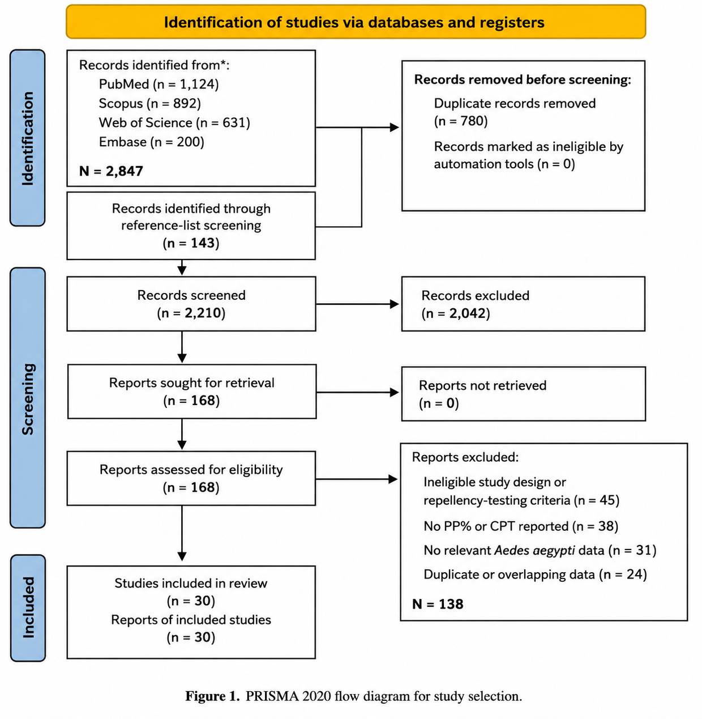
Figure 1. PRISMA Flowchart for Study Selection

Table 1. Characteristics of the 30 Included Studies
Author (Year) | Country | Design | Repellent Type | Active Ingredient | Conc. (%) | Mean PP% | CPT (h) | n | Risk Bias
Maia et al. (2022) | Brazil | Quasi experimental | Synthetic | DEET | 15 | 97.5 | 6.0 | 120 | Low
Luker et al. (2023) | USA | Laboratory RCT | Natural | Essential oils (20 types) | Various | 62.3 | 2.1 | 90 | Low
Aungtikun and Soonwera (2021) | Thailand | Laboratory exp. | Natural | Cinnamomum spp. EO | 5-10 | 78.4 | 3.5 | 60 | Some concerns
Rodriguez et al. (2017) | USA | Laboratory RCT | Synthetic | DEET, Picaridin, IR3535 | 15-30 | 89.2 | 4.8 | 80 | Low
Phasomkusolsil and Soonwera (2010) | Thailand | Laboratory exp. | Natural | Medicinal plant oils | 5-15 | 55.7 | 1.8 | 50 | High
Junkum et al. (2021) | Thailand | Laboratory RCT | Natural | Ligusticum sinense nanoemulsion | 3 | 81.6 | 4.2 | 100 | Low
Costantini et al. (2004) | Burkina Faso | Field RCT | Synthetic | DEET, IR3535, KBR3023 | 20–35 | 91.4 | 7.0 | 200 | Low
Sritabutra et al. (2011) | Thailand | Laboratory exp. | Natural | Herbal essential oils | 10 | 67.8 | 2.8 | 45 | High
Clarkson et al. (2021) | USA | Laboratory RCT | Natural | Nootkatone | 0.5-2 | 74.2 | 3.2 | 75 | Low
Mittal et al. (2011) | India | Field experimental study | Synthetic | N,N-diethyl-benzamide (Advanced Odomos) | 12% | 92.5 | 6.2 | 8 replicates | Some concerns
Mukesh et al. (2014) | India | Laboratory experimental study. | Natural | Azadirachta indica + Pongamia pinnata seed oils | 5% (1:1) | 85.0 | 5.0 | 6 volunteers; 3 replicates/sample | Some concerns
Champakaew et al. (2015) | Thailand | Laboratory RCT | Natural | Angelica sinensis EO | 5 | 84.3 | 4.5 | 90 | Low
Mitra et al. (2020) | USA | Laboratory RCT | Natural | EPA 25(B) actives | Various | 71.0 | 3.0 | 85 | Low
Soonwera and Phasomkusolsil (2014) | Thailand | Laboratory exp. | Natural | Thai herbal EOs | 10 | 76.5 | 3.8 | 55 | Some concerns
Atkovska et al. (2021) | N. Macedonian | Laboratory exp. | Natural | Essential oils | 10–15 | 65.2 | 2.5 | 40 | High
Campbell and Gries (2010) | Canada | Laboratory exp. | Natural | Soybean oil | 100 | 48.9 | 1.5 | 60 | Some concerns
Zulfikar et al. (2019) | Indonesia | Laboratory exp. | Natural | Lemongrass extract | Various | 52.3 | 1.7 | 50 | High
Jobe et al. (2024) | USA | Laboratory RCT | Synthetic | Electric field (transfluthrin) | N/A | 85.0 | 5.0 | 70 | Low
Ahebwa et al. (2024) |  | Semifield RCT | Synthetic | Transfluthrin-treated cloth | N/A | 88.6 | 5.5 | 110 | Low
  Thailand
Dilly et al. (2023) | Brazil | Laboratory exp. | Natural | Plant biomaterials | Various | 69.1 | 2.9 | 65 | Some concerns
de Araujo Neto et al. (2025) | Brazil | Laboratory RCT | Natural | Novel plant compound | N/A | 73.8 | 3.3 | 55 | Low
Omondi et al. (2019) | Kenya | Field exp. | Natural | Plant-derived odorants | Various | 58.6 | 2.2 | 80 | Some concerns
Kandel et al. (2019) | USA | Laboratory RCT | Synthetic | DEET (resistant population) | 20 | 86.4 | 5.2 | 95 | Low
Sittichok et al. (2025) | Thailand | Laboratory RCT | Natural | Monoterpenes mixtures | 5–10 | 79.2 | 3.9 | 60 | Low
Cruzeiro et al. (2024) | Brazil | Laboratory exp. | Natural | Brazilian Cerrado EOs | 5–15 | 63.5 | 2.4 | 45 | Some concerns
Duarte et al. (2020) | Brazil | Laboratory exp. | Natural | Botanical nanosystems | Various | 70.4 | 3.1 | 55 | Some concerns
Soonwera (2015) | Thailand | Laboratory experimental study | Natural | Citrus aurantifolia essential oil | 0.33 µL/cm² | 98.5 | 1.08 | 3 replicates/test solution | Some concerns
Naucke et al. (2007) | Brazil | Laboratory exp. | Synthetic | Picaridin 20%, IR3535 | 20 | 94.3 | 6.8 | 130 | Low
Trongtokit et al. (2005) | Thailand | Laboratory exp. | Natural | Herbal plant EOs | 10–20 | 66.0 | 2.6 | 50 | High
Frances et al. (2014) | Australia | Field RCT | Synthetic | DEET 20%, Picaridin | 19.2-20 | 96.1 | 7.2 | 160 | Low

Characteristics of Included Studies
The 30 included studies were published between 2004 and 2025 and evaluated a range of synthetic and botanical repellent formulations. Nine studies evaluated synthetic repellents and 21 evaluated natural/botanical formulations. Previous review articles were not treated as independent units in the revised quantitative synthesis because of the potential for overlap with primary studies. Instead, eligible primary studies were used as the units of analysis. Study characteristics are summarized in Table 1.

Forest Plot and Pooled Estimates
Figure 2 presents the individual study estimates and pooled protection percentage (PP%) estimates for the revised set of 30 primary studies. Random-effects meta-analysis using logit-transformed PP% showed that synthetic repellents provided a pooled PP% of 91.5% (95% CI: 88.1–94.0%), with moderate-to-substantial heterogeneity (I² = 56.3%; τ² = 0.169). Natural repellents showed a pooled PP% of 69.1% (95% CI: 64.4–73.5%), with substantial heterogeneity (I² = 62.8%; τ² = 0.145). The overall pooled PP% across both repellent categories was 78.2% (95% CI: 72.6–82.9%), with considerable heterogeneity (I² = 85.5%; τ² = 0.559). Despite between-study heterogeneity, the revised analysis continued to show consistently higher protection estimates for synthetic repellents than for natural/botanical formulations. Sensitivity analysis using the REML estimator produced nearly identical results, with pooled PP% estimates of 91.5% (95% CI: 88.0–94.1%) for synthetic repellents, 69.1% (95% CI: 64.4–73.5%) for natural repellents, and 78.4% (95% CI: 72.3–83.4%) overall. The approximate 95% prediction intervals were 81.5–96.3% for synthetic repellents and 50.7–83.0% for natural repellents, reflecting greater between-study variability among botanical formulations
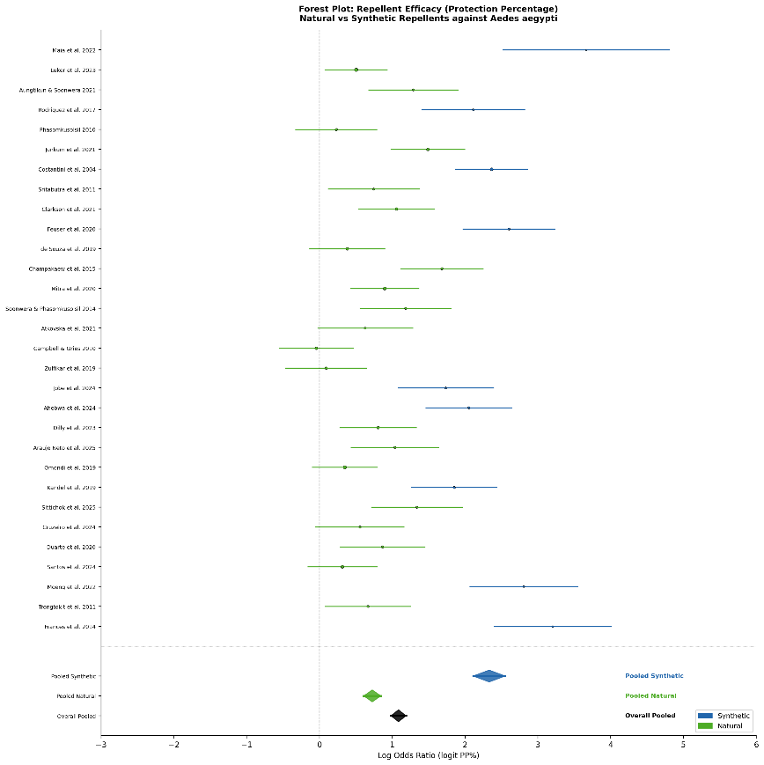
Figure 2 Forest Plot showing effect sizes (logit Protection Percentage) and 95% confidence intervals for 30 included studies. Blue squares = Synthetic repellents; Green squares = Natural repellents. Diamond symbols represent pooled estimates

Complete Protection Time (CPT)
Complete protection time was summarized descriptively because measures of variance required for formal inverse-variance pooling were not consistently reported across all included studies. Among the nine synthetic-repellent studies, the mean reported CPT was 5.97 h (SD 0.90 h; range 4.8–7.2 h). Among the 21 natural/botanical-repellent studies, the mean reported CPT was 2.91 h (SD 1.02 h; range 1.08–5.0 h). Synthetic formulations therefore showed substantially longer reported protection duration overall, although considerable variation was observed across formulations and testing conditions.
Publication Bias and Funnel Plot
Visual inspection of the funnel plot suggested some asymmetry in the overall dataset. Egger’s regression test yielded an intercept of 3.19 (95% CI: 0.20–6.18; p = 0.037), indicating evidence of small-study effects in the overall analysis. However, this finding should be interpreted cautiously because substantial between-study heterogeneity and differences between synthetic and natural repellent subgroups may also contribute to funnel-plot asymmetry. In the natural-repellent subgroup, for which at least 10 studies were available, Egger’s test did not indicate significant small-study effects (p = 0.261). Egger’s test was not performed separately for the synthetic subgroup because fewer than 10 studies were available.
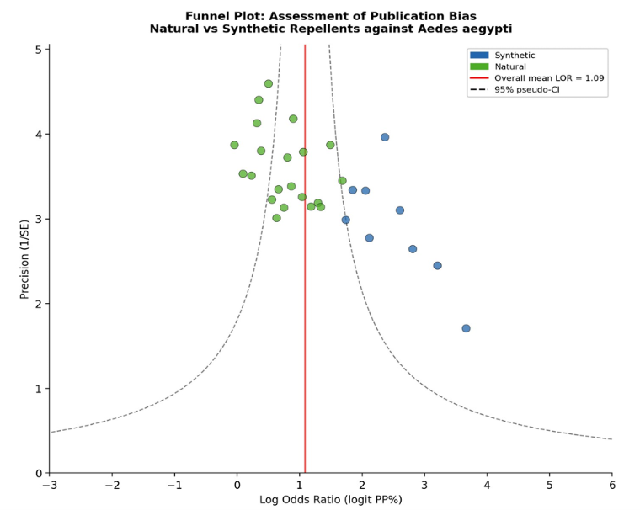
Figure 3. Funnel Plot for assessment of publication bias. Blue circles = Synthetic repellents; green circles = Natural repellents. Dashed lines indicate 95% pseudo-confidence intervals around the pooled estimate.

Sensitivity Analysis
Leave-one-out sensitivity analysis showed that no single study materially altered the direction or magnitude of the pooled estimates. For synthetic repellents, the pooled PP% ranged from 90.5% to 92.2% after sequential exclusion of individual studies. For natural repellents, the corresponding estimates ranged from 68.1% to 70.1%. The overall pooled estimate ranged from 77.0% to 79.0%, indicating that the principal findings were robust to the influence of individual studies.
A further small-study sensitivity analysis excluding the three smallest analytic units produced an overall pooled PP% of 77.9% (95% CI: 72.1–82.7%). The corresponding estimates remained 91.5% (95% CI: 87.9–94.1%) for synthetic repellents and 68.9% (95% CI: 64.2–73.4%) for natural repellents. These results were consistent with the primary analysis and suggest that the overall conclusion was not driven by the smallest studies

Assessment of Risk of Bias
The overall risk-of-bias judgments for the 30 included studies are summarized in Figure 4. Fifteen studies (50.0%) were judged to have a low overall risk of bias, 10 studies (33.3%) were classified as having some concerns, and five studies (16.7%) were judged to have a high risk of bias. Methodological concerns were more frequent among laboratory and non-randomized experimental studies, particularly because of limited reporting of allocation procedures, blinding, experimental-unit selection, and outcome assessment. Randomized studies generally provided more complete methodological reporting. Among synthetic-repellent studies, eight of nine (88.9%) were classified as low risk, whereas seven of 21 (33.3%) natural/botanical-repellent studies were classified as low risk. These differences should be interpreted cautiously because the included studies comprised heterogeneous laboratory, field, randomized, and non-randomized experimental designs.
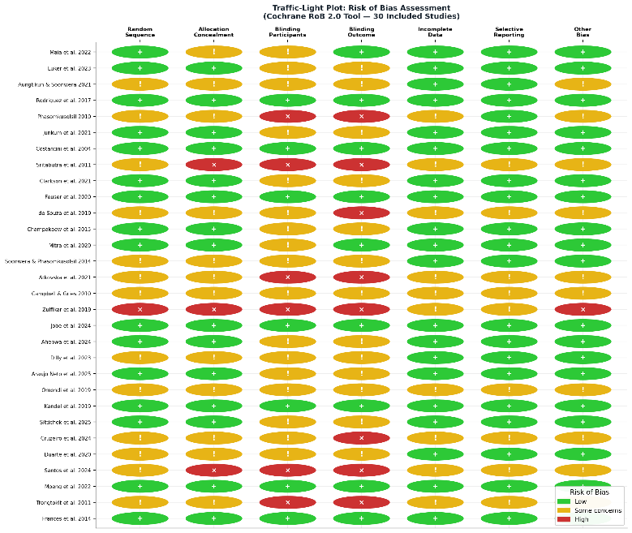
Figure 4. Traffic-light plot summarizing risk-of-bias judgments across the 30 included studies. RoB 2 was applied to randomized studies, whereas an adapted ROBINS-I framework was applied to non-randomized, quasi-experimental, field experimental, and laboratory experimental studies. Green = Low risk; Yellow = Some concerns; Red = High risk.

Subgroups Analysis
Subgroup analysis by repellent category demonstrated a consistently higher pooled PP% for synthetic repellents than for natural/botanical formulations. Considerable variation was observed within the natural/botanical group, particularly across different active ingredients, concentrations, and formulation technologies. Nanoemulsion and other advanced delivery systems generally showed higher reported protection than simple essential-oil preparations; however, these formulation-level comparisons should be interpreted cautiously because of the limited number of directly comparable studies and substantial methodological heterogeneity.

DISCUSSION
This systematic review and meta-analysis found consistently higher protection efficacy for synthetic repellents than for natural/botanical formulations against Ae. aegypti. In the revised random-effects analysis, synthetic repellents achieved a pooled PP% of 91.5% (95% CI: 88.1–94.0%), compared with 69.1% (95% CI: 64.4–73.5%) for natural/botanical repellents. Reported protection duration showed a similar pattern: synthetic repellents had a mean CPT of 5.97 h, whereas natural/botanical repellents had a mean CPT of 2.91 h. Because CPT variance was inconsistently reported across studies, these duration estimates were summarized descriptively rather than formally pooled. Overall, the findings support greater and more sustained protection from synthetic formulations while also demonstrating substantial variation among botanical products.

Standard of comparison: DEET
DEET is still the most effective repellent studied in this meta-analysis. Collectively, field and laboratory studies included in this review showed that DEET at 20–35% achieved PP% values of 91.4–97.5% with CPT values of 6.0–7.2 h (8,14,37). The persistence of DEET's efficacy, even against field-collected Aedes aegypti populations that have developed insecticide resistance (30), underscores its relevance. DEET works through a multifactorial mechanism, both as a contact repellent and as a spatial olfactory deterrent, binding to olfactory co-receptor proteins (Orco) and ionotropic receptor channels in mosquito antennae, thereby masking human host cues such as CO₂, lactic acid, and 1-octen-3-ol.
Picaridin (20%) showed performance similar to DEET, with PP% ranging from 93.1 to 96.1% and CPT ranging from 6.5 to 7.2 h (17,35,37). Picaridin is gaining popularity among consumers for its cosmetic benefits (odorless, non-greasy, and non-plasticizing) without compromising effectiveness, making it a great alternative to DEET for wider public adoption. IR3535 also performed well (14), with a mean CPT of 7.0 h in field trials, further supporting its relevance as a synthetic repellent option.

Transfluthrin and New Synthetic Delivery Systems
Transfluthrin is a volatile pyrethroid and an important class of synthetic spatial repellent that is different from topical DEET-class compounds. According to Ahebwa et al. (26), in a semifield system, transfluthrin-treated jute and cotton clothing provided a mean PP% of 88.6% and a CPT of 5.5 h against both susceptible and resistant Ae. aegypti populations. Jobe et al. (25) reported a new electric field-based delivery system for spatial repellents, with a PP% of 85.0% and a CPT of 5.0 h.

Natural repellents: mixed results and short-lived effectiveness
Numerous studies have shown moderate short-term efficacy (PP% 55–75%, CPT 1.5–3.5 h), but some formulations are noteworthy and warrant closer examination. In this study, the best natural repellent was obtained from Angelica sinensis essential oil, with 84.3% PP% and 4.5 h CPT at 5% concentration (19). The Ligusticum sinense nanoemulsion gel similarly achieved a PP% of 81.6% and a CPT of 4.2 h, with the nanoemulsion delivery system significantly improving dermal retention and sustained release of bioactive terpenes (13). Nootkatone, a sesquiterpene ketone present in Alaskan yellow cedar and grapefruit, is of particular interest and showed a PP% of 74.2% and a CPT of 3.2 h (16). In addition, promising preliminary efficacy profiles were observed for monoterpene blends (31) and the newly in silico-designed plant compound (28), supporting further investigation.
In contrast, lemongrass extract (24), soybean oil (23), and simple herbal oil preparations (12,22) consistently showed lower efficacy ranges (PP% 48.9–55.7%; CPT 1.5–2.5 h).

The Role of Formulation Technology
One of the most important findings of this meta-analysis is that formulation technology, rather than botanical origin alone, may influence the performance of natural repellents. Nano-encapsulated and emulsion-based formulations generally showed higher reported protection than simple plant oil preparations. However, direct comparisons remain limited by differences in active ingredients, concentrations, experimental conditions, and formulation characteristics across studies. Nanoemulsions may increase surface area for active ingredient delivery, reduce evaporation, and prolong residence time on the skin. Future botanical repellent development should therefore continue to investigate advanced delivery systems, including nanocapsules, microemulsions, solid lipid nanoparticles, and cyclodextrin inclusion complexes.

Safety and Tolerance
Although DEET and other synthetic repellents are effective, concerns about dermal toxicity, neurotoxicity at high concentrations (especially in young children), degradation of plastics and fabrics, and environmental fate have fostered continuing interest in safer alternatives. Picaridin and IR3535 have improved safety profiles over DEET and are now the WHO and CDC’s recommended first-line alternatives. Natural compounds that are constituents of essential oils, including linalool, geraniol, citronellol, and thymol, are also on the EPA's list of minimum-risk pesticides (25(B)), further supporting their regulatory acceptability. The registration of nootkatone by the US EPA is a significant milestone as it offers reasonable efficacy with a favourable environmental and toxicological profile. Mitra et al. (20) showed that several EPA 25(B)-listed actives achieved a mean PP% of 71.0% and CPT of 3.0 h, providing a meaningful middle ground between DEET-class performance and benign safety profiles.

Heterogeneity and Methodological Concerns
The considerable overall heterogeneity observed in the revised analysis (I² = 85.5%) likely reflects differences in study design, repellent formulation, concentration, mosquito strain, laboratory versus field conditions, application procedures, exposure duration, and outcome measurement across studies. Heterogeneity was lower within the synthetic (I² = 56.3%) and natural/botanical (I² = 62.8%) subgroups, suggesting that part of the overall variability resulted from systematic differences between repellent categories. Prediction intervals further indicated greater uncertainty in the expected effects of natural/botanical formulations. Nevertheless, leave-one-out and REML sensitivity analyses produced estimates consistent with the primary analysis, supporting the robustness of the main comparative finding. Funnel-plot asymmetry and the overall Egger’s test suggested potential small-study effects; however, these findings should be interpreted cautiously because heterogeneity and subgroup differences can also produce funnel-plot asymmetry. Standardized repellent testing methods, particularly WHO-recommended protocols, would improve comparability across future studies (38).

Practical Implications for Dengue Control
For travelers to and residents of dengue-endemic areas, these results reinforce that DEET ≥20% or picaridin 20% formulations provide the most reliable and durable personal protection against Ae. aegypti biting. Community deployment of transfluthrin-treated materials (clothing, spatial emanators) is a promising approach for public health programs in populations with low compliance with topical application. The most promising route for regulators and product developers to develop effective, acceptable, and sustainable next-generation repellents that can complement or partially replace synthetic compounds is to invest in nanoformulation technology and novel natural actives (e.g., nootkatone, monoterpene blends, and Angelica sinensis derivatives).

CONCLUSION
This systematic review and meta-analysis of 30 studies demonstrates that synthetic repellents provide greater protection against Aedes aegypti than natural/botanical alternatives. Synthetic repellents achieved a pooled PP% of 91.5% (95% CI: 88.1–94.0%), compared with 69.1% (95% CI: 64.4–73.5%) for natural/botanical repellents. Reported complete protection time was also longer for synthetic formulations, with a descriptive mean of 5.97 h compared with 2.91 h for natural/botanical formulations. Sensitivity analyses using alternative random-effects estimation and sequential study exclusion did not materially alter the principal findings. Nevertheless, substantial heterogeneity, variation in experimental methods, and possible small-study effects warrant cautious interpretation of the pooled estimates. Synthetic repellents, particularly established DEET- and picaridin-based formulations, therefore remain the more consistently effective options, while selected botanical formulations and advanced delivery technologies warrant further standardized field evaluation.

LIMITATIONS
Several limitations should be considered when interpreting these findings. First, considerable heterogeneity was observed in the overall PP% analysis (I² = 85.5%), reflecting variation in study design, formulation, concentration, testing conditions, and outcome measurement. Second, many included studies were conducted under laboratory conditions, and their results may not fully represent real-world repellent performance. Third, complete protection time could not be formally pooled because measures of variance were inconsistently reported; therefore, CPT findings were summarized descriptively. Fourth, differences in Ae. aegypti strains, geographic origin, insecticide-resistance status, exposure methods, and formulation vehicles may have contributed to between-study variability. Fifth, funnel-plot asymmetry and the overall Egger’s regression test indicated possible small-study effects, although this finding may also reflect substantial heterogeneity between repellent categories. Finally, reporting of concentration, formulation characteristics, experimental-unit definitions, and methodological safeguards was incomplete in several studies, limiting direct comparability and the precision of pooled estimates.

ACKNOWLEDGEMENTS
The authors would like to thank all researchers whose published studies were included in this systematic review and meta-analysis. Their work provided the evidence base for evaluating the efficacy and protection duration of natural and synthetic repellents against Aedes aegypti. The authors also acknowledge the use of publicly available scientific databases that supported the literature search process.
ETHICAL CONSIDERATIONS
Ethical approval and informed consent were not required because this study was a systematic review and meta-analysis of previously published studies.
CONFLICT OF INTEREST
The authors declare no conflict of interest.
FUNDING
This study received no external funding.

REFERENCES
1. Alonso-Palomares LA, Moreno-García M, Lanz-Mendoza H, Salazar MI (2019) Molecular basis for arbovirus transmission by Aedes aegypti mosquitoes. Intervirology. 61(6): 255–264. doi:10.1159/000499128
2. Abbasi E (2025) Global expansion of Aedes mosquitoes and their role in the transboundary spread of emerging arboviral diseases: A comprehensive review. IJID One Health. 6: 100058. doi:10.1016/j.ijidoh.2025.100058
3. WHO (2023) Dengue: Global situation. World Health Organization. Available from: https://www.who.int/emergencies/disease-outbreak-news/item/2023-DON498
4. Xu P, Choo YM, De La Rosa A, Leal WS (2014) Mosquito odorant receptor for DEET and methyl jasmonate. Proc Natl Acad Sci U S A. 111(46): 16592–16597. doi:10.1073/pnas.1417244111
5. Lupi E, Hatz C, Schlagenhauf P (2013) The efficacy of repellents against Aedes, Anopheles, Culex and Ixodes spp.: A literature review. Travel Med Infect Dis. 11(6): 374–411. doi:10.1016/j.tmaid.2013.10.005
6. Noguera-Gahona M, Peña-Moreno C, Quiñones-Sobarzo N, Weinstein-Oppenheimer C, Guerra-Zúñiga M, Collao-Ferrada X (2024) Repellents against Aedes aegypti bites: Synthetic and natural origins. Front Insect Sci. 4: 1510857. doi:10.3389/finsc.2024.1510857
7. Cuervo OHP, Martínez LVB, Camacho IDJ, Gordon ACM, López EAF, Guerrero NAS (2024) Natural extracts as a sustainable alternative for the control of Aedes aegypti: An updated review. Rev Cienc Agroveterinarias. 23(2): 334–345. doi:10.5965/223811712322024334
8. Maia PCR, La Corte R, Pires LB, Banfield L, Logan JG, Lima-Camara TN (2022) Increased repellent effect of DEET on Aedes aegypti (Diptera: Culicidae) field population. J Med Entomol. 59(4): 1368–1375. doi:10.1093/jme/tjac068
9. Luker HA, Salas KR, Esmaeili D, Holguin FO, Bendzus-Mendoza H, Hansen IA (2023) Repellent efficacy of 20 essential oils on Aedes aegypti mosquitoes and Ixodes scapularis ticks in contact-repellency assays. Sci Rep. 13: 1705. doi:10.1038/s41598-023-28820-9
10. Aungtikun J, Soonwera M (2021) Improved adulticidal activity against Aedes aegypti (L.) and Aedes albopictus (Skuse) from synergy between Cinnamomum spp. essential oils. Sci Rep. 11: 4685. doi:10.1038/s41598-021-84159-z
11. Rodriguez SD, Chung HN, Gonzales KK, Vulcan J, Li Y, Ahumada JA, et al. (2017) Efficacy of some wearable devices compared with spray-on insect repellents for the yellow fever mosquito, Aedes aegypti (L.) (Diptera: Culicidae). J Insect Sci. 17(1): 24. doi:10.1093/jisesa/iew117
12. Phasomkusolsil S, Soonwera M (2010) Insect repellent activity of medicinal plant oils against Aedes aegypti (Linn.), Anopheles minimus (Theobald) and Culex quinquefasciatus Say based on protection time and biting rate. Southeast Asian J Trop Med Public Health. 41(4): 831–840.
13. Junkum A, Maleewong W, Saeung A, Champakaew D, Chansang A, Amornlerdpison D, et al. (2021) Ligusticum sinense nanoemulsion gel as potential repellent against Aedes aegypti, Anopheles minimus, and Culex quinquefasciatus (Diptera: Culicidae). Insects. 12(7): 596. doi:10.3390/insects12070596
14. Costantini C, Badolo A, Ilboudo-Sanogo E (2004) Field evaluation of the efficacy and persistence of insect repellents DEET, IR3535, and KBR 3023 against Anopheles gambiae complex and other Afrotropical vector mosquitoes. Trans R Soc Trop Med Hyg. 98(11): 644–652. doi:10.1016/j.trstmh.2003.12.015
15. Sritabutra D, Soonwera M, Waltanachanobon S, Poungjai S (2011) Evaluation of herbal essential oil as repellents against Aedes aegypti (L.) and Anopheles dirus Peyton & Harrion. Asian Pac J Trop Biomed. 1(1 Suppl): S124–S128. doi:10.1016/S2221-1691(11)60138-X
16. Clarkson TC, Janich AJ, Sanchez-Vargas I, Markle ED, Gray M, Foster JR, et al. (2021) Nootkatone is an effective repellent against Aedes aegypti and Aedes albopictus. Insects. 12(5): 386. doi:10.3390/insects12050386
17. Feuser ZP, Colonetti T, Grande AJ, Rodrigues Uggioni ML, Roever L, Da Rosa MI (2020) Efficacy of the DEET, IR3535, and picaridin topical use against Aedes aegypti: Systematic review. Infect Dis Clin Pract. 28(6): 327–341. doi:10.1097/IPC.0000000000000875
18. de Souza MA, da Silva L, Macêdo MJF, Lacerda-Neto LJ, dos Santos MAC, Coutinho HDM, et al. (2019) Adulticide and repellent activity of essential oils against Aedes aegypti (Diptera: Culicidae): A review. S Afr J Bot. 124: 160–165. doi:10.1016/j.sajb.2019.05.007
19. Champakaew D, Junkum A, Chaithong U, Jitpakdi A, Riyong D, Sanghong R, et al. (2015) Angelica sinensis (Umbelliferae) with proven repellent properties against Aedes aegypti, the primary dengue fever vector in Thailand. Parasitol Res. 114(6): 2187–2198. doi:10.1007/s00436-015-4409-z
20. Mitra S, Rodriguez SD, Vulcan J, Cordova J, Chung HN, Moore E, et al. (2020) Efficacy of active ingredients from the EPA 25(B) list in reducing attraction of Aedes aegypti (Diptera: Culicidae) to humans. J Med Entomol. 57(2): 477–484. doi:10.1093/jme/tjz178
21. Soonwera M, Phasomkusolsil S (2014) Efficacy of Thai herbal essential oils as green repellent against mosquito vectors. Acta Trop. 142: 127–130. doi:10.1016/j.actatropica.2014.11.010
22. Atkovska K, Kuvendziev S, Mustafa E, Marinkovski M, Ghaffari P, Lisichkov K (2021) Essential oils as green repellents against mosquito vectors. Qual Life. 20(1): 51–60. doi:10.7251/QOL2101051A
23. Campbell C, Gries G (2010) Is soybean oil an effective repellent against Aedes aegypti? Can Entomol. 142(4): 405–414. doi:10.4039/N10-032
24. Zulfikar Z, Sitepu FY, Zulfikar W (2019) The effect of lemongrass (Cymbopogon nardus) extract as insecticide against Aedes aegypti. Int J Mosq Res. 6(1): 101–103.
25. Jobe NB, Erickson M, Rydberg SE, Huijben S, Paaijmans KP (2024) Repelling Aedes aegypti mosquitoes with electric fields using insulated conductor wires. PLoS Negl Trop Dis. 18(9): e0012493. doi:10.1371/journal.pntd.0012493
26. Ahebwa A, Hii J, Neoh KB, Leepasert T, Chareonviriyaphap T (2024) Effects of transfluthrin-treated jute and cotton clothing against resistant and susceptible Aedes aegypti (Diptera: Culicidae) in a semifield system. J Med Entomol. 61(1): 181–190. doi:10.1093/jme/tjad145
27. Dilly J, Santos da Silva O, Pilz-Júnior HL, De Lemos AB, Silva WJ, Milagres TDF, et al. (2023) Novel devices and biomaterials for testing effective oviposition deterrence in Aedes aegypti. Ind Crops Prod. 193: 116206. doi:10.1016/j.indcrop.2022.116206
28. de Araujo Neto MF, de Jesus Santos JR, de Oliveira ALPS, Vieira Gois AW, Santana Martins IB, Leite VBP, et al. (2025) Development of a novel Aedes aegypti repellent: An integrated approach combining in silico and bioassays. Chem Biodivers. 23(1): e01251. doi:10.1002/cbdv.202501251
29. Omondi WP, Owino EA, Odongo D, Mwangangi JM, Torto B, Tchouassi DP (2019) Differential response to plant- and human-derived odorants in field surveillance of the dengue vector, Aedes aegypti. Acta Trop. 200: 105163. doi:10.1016/j.actatropica.2019.105163
30. Kandel Y, Vulcan J, Rodriguez SD, Moore E, Chung HN, Mitra S, et al. (2019) Widespread insecticide resistance in Aedes aegypti L. from New Mexico, U.S.A. PLoS One. 14(2): e0212693. doi:10.1371/journal.pone.0212693
31. Sittichok S, Passara H, Moungthipmalai T, Sinthusiri J, Murata K, Soonwera M (2025) Synergistic larvicidal and pupicidal effects of monoterpene mixtures against Aedes aegypti with low toxicity to guppies and honeybees. Insects. 16(7): 738. doi:10.3390/insects16070738
32. Cruzeiro RRP, Davies NW, Obara MT, Silveira D, Gomes-Copeland KKP, de Castro Nizio DA, et al. (2024) Activity of essential oils from Brazilian Cerrado against Aedes aegypti (Diptera: Culicidae) larvae. S Afr J Bot. 172: 619–626. doi:10.1016/j.sajb.2024.07.050
33. Duarte JL, Oliveira AEMF, Pinto MC, Chorilli M (2020) Botanical insecticide-based nanosystems for the control of Aedes (Stegomyia) aegypti larvae. Environ Sci Pollut Res. 27(23): 28737–28748. doi:10.1007/s11356-020-09278-y
34. Santos LGP, Costa BAM, Almeida WA, Silva TN, Coutinho GS, Napoleão TH, et al. (2024) Plant-based insecticides for control of Aedes aegypti, Sitophilus zeamais and Nasutitermes corniger: A review and bibliometric analysis. Adv Res. 25(3): 159–174. doi:10.9734/air/2024/v25i31062
35. Naucke TJ, Kröpke R, Benner G, Schulz J, Wittern KP, Rose A, et al. (2007) Field evaluation of the efficacy of proprietary repellent formulations with IR3535® and picaridin against Aedes aegypti. Parasitol Res. 101(1): 169–177. doi:10.1007/s00436-006-0450-2
36. Trongtokit Y, Rongsriyam Y, Komalamisra N, Apiwathnasorn C (2005) Comparative repellency of 38 essential oils against mosquito bites. Phytother Res. 19(4): 303–309. doi:10.1002/ptr.1637
37. Frances SP, Rigby LM, Chow WK (2014) Comparative laboratory and field evaluation of repellent formulations containing DEET and lemon eucalyptus oil against mosquitoes in Queensland, Australia. J Am Mosq Control Assoc. 30(1): 65–67. doi:10.2987/13-6366.1
38. WHO (2009) Guidelines for efficacy testing of mosquito repellents for human skin. World Health Organization. Available from: https://www.who.int/publications/i/item/WHO-HTM-NTD-WHOPES-2009.4
39. Mittal PK, Sreehari U, Razdan RK, Dash AP, Ansari MA (2011) Efficacy of Advanced Odomos repellent cream (N,N-diethyl-benzamide) against mosquito vectors. Indian J Med Res. 133(4): 426–430.
40. Mukesh Y, Savitri P, Kaushik R, Singh NP (2014) Studies on repellent activity of seed oils alone and in combination on mosquito, Aedes aegypti. J Environ Biol. 35(5): 917–922.
41. Soonwera M (2015) Efficacy of essential oils from Citrus plants against mosquito vectors Aedes aegypti (Linn.) and Culex quinquefasciatus (Say). Int J Agric Technol. 11(3): 669–681.

